# Lab Assignment 7 (05/05/2013) – Report

Student: Manuel Diaz   
ID: f99543083

**Exercise 1**. Geometry Model and deformation Result in Matlab (using scale factor: 1E6)

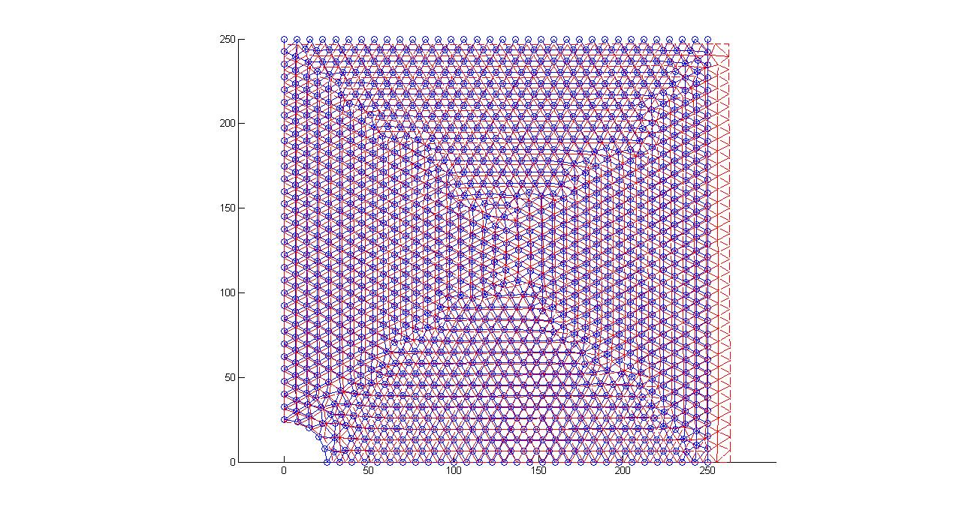

Comparison of displacements and stress results between Matlab and Abaqus:

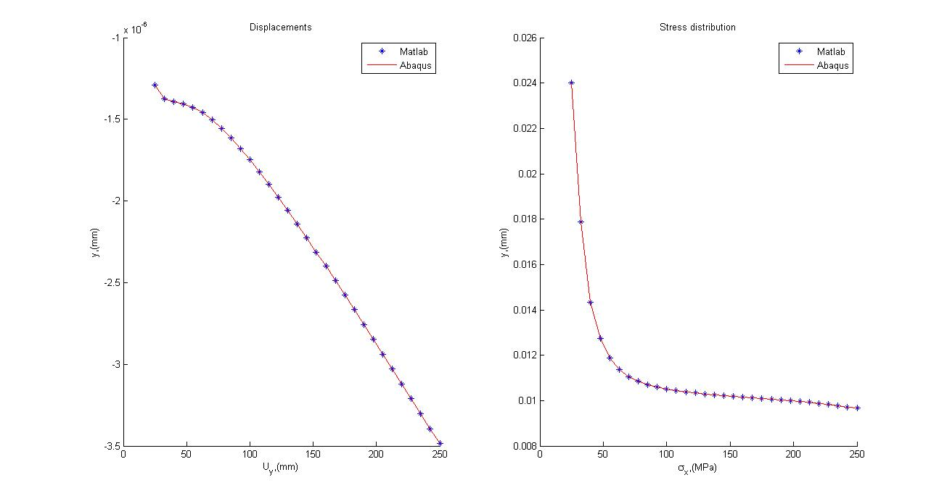

We observe a great agreement between our calculations in Matlab and the results obtained with Abaqus.

**Exercise 2**. Geometry Model and deformation results in Matlab (using scale factor: 1E3)

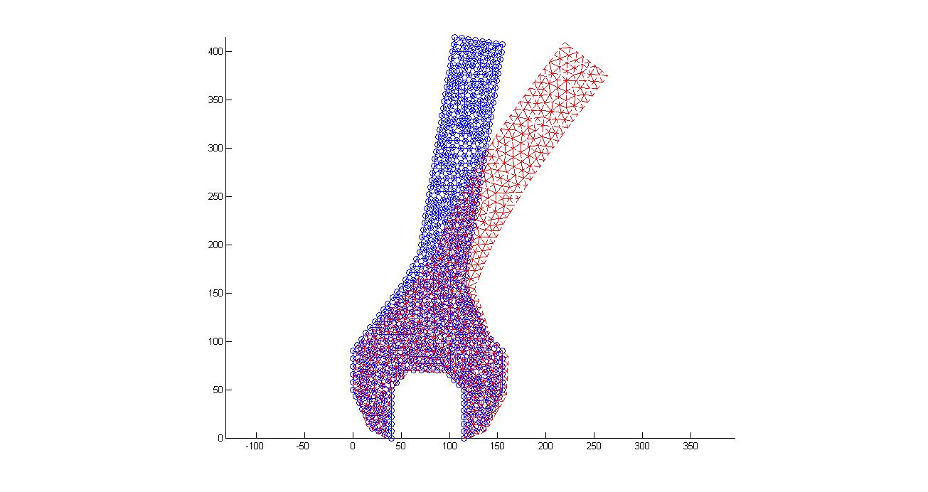

Comparison of displacements and stress results between Matlab and Abaqus,

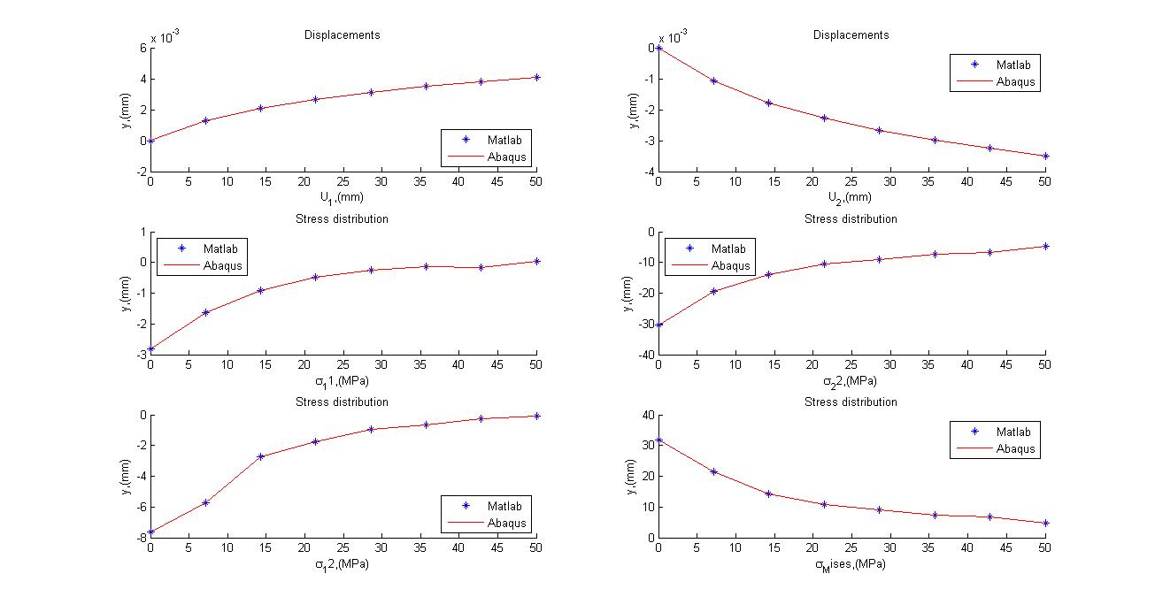

Again, the agreement is very good between our calculations in Matlab and the results obtained with Abaqus.